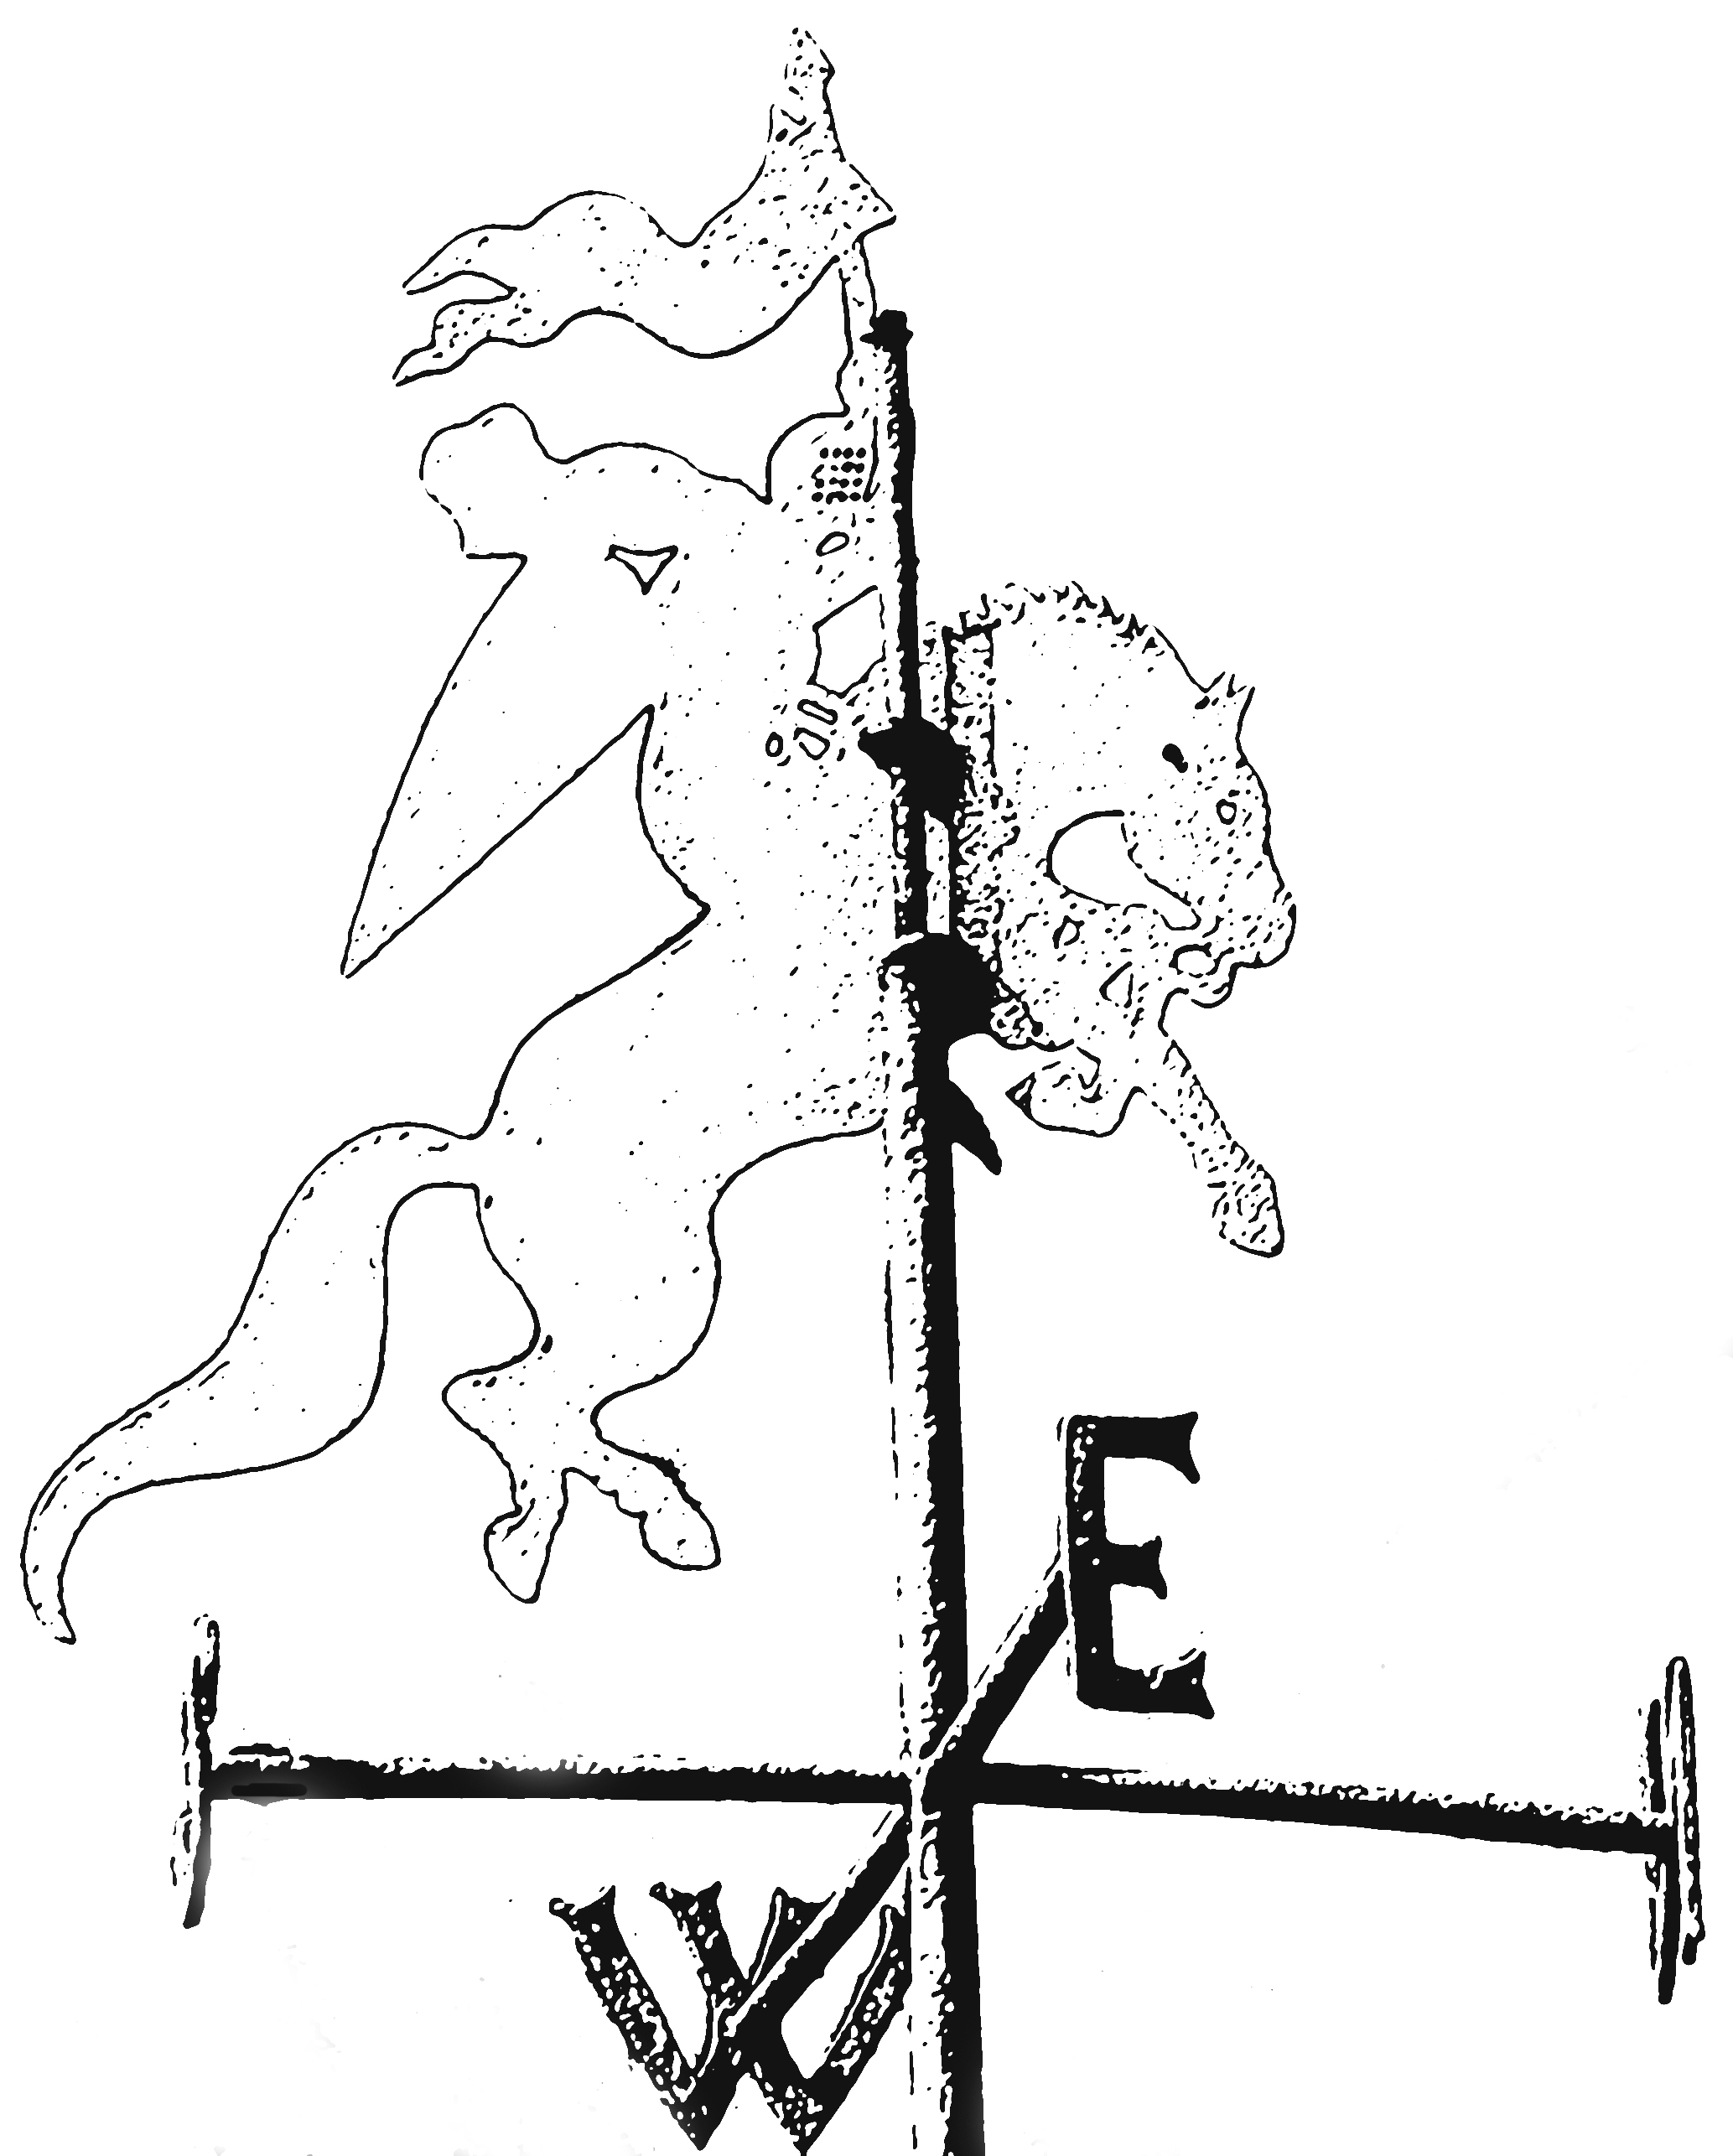
Seend Community Land & Asset Trust

Seend Community Land
&
Asset Trust

-----------------------------------------------------------------------------------------------------------
An Invitation to Join!
The Seend Community Land & Asset Trust is an open membership, not-for-profit organisation.
Any individual over 16 who lives or works in the Civil Parish of Seend, Wiltshire can join.
Membership costs just £1 for life. To join please fill out the details below, put your £1 coin in
the envelope provided and provide your details on the envelope form. Return the form and
envelope to: Bradley Farm, Rusty Lane, Seend SN12 6NS.
Please include a £1 coin. A personal receipt will be issued with your membership certificate.
I live in the parish of Seend and wish to apply for membership of the  Seend Community Land & Asset Trust. Please indicate if you live in Seend > |  | Yes/No
First name:
Last name:
Address line 1:
Address line 2:
Address line 3:
Post code:
Email:
I am interested in voluntary work on behalf of the CLT. |  | Yes/No
I do not live in the parish of Seend but wish to become a ‘friend’ of the CLT |  | Yes/No
I agree to the CLT processing of my personal data for CLT communication
purposes only. (Data Privacy Policy is available at:
https://www.seendclt.org/privacy-policy.html)
Please enter Yes or No in the box.
Telephone:
Signature: Date:
For office use only:
Membership Number:
£1 received:
info@seendclt.org / www.seendclt.org

What does Seend CLT aim to achieve?
- Provide permanently affordable housing for local people through all their life stages.

- Acquire, develop and care for assets that benefit our community
Why should I join?
The more members the CLT has, the stronger it is.
With more members, we have more credibility to apply for loans, to lobby the local authority for support and to be representative of our community. Our CLT is an active full member of the National CLT Network.
How do I become a member?
Any adult of 16 years of age and over who lives in the parish of Seend can become a member for £1 for life
The more who join, the stronger the CLT.

Fill out the form on the back of this leaflet, or download from: www.seendclt.org and join today!

What would I get out of it?
- Become an active member of our CLT and meet like-minded people who work to provide affordable homes for Seend people.
- Join the housing conversation and help design the housing required.
- Share in the ownership and management of our community assets.
- Be part of achieving improvements for our parish for the benefit of our community
- Receive regular updates and newsletters.
Who manages all of this?
- The CLT is incorporated as a Community Interest Company (CIC) with a board of 5 directors who are local people. All CLT members, including the Board, work voluntarily. Any surplus funds are used for community benefit.

- The CIC works in conjunction with Seend Parish Council. CIC Articles of Association are available at: https://www.seendclt.org/articles-of-association.html
- Unless CLTs are themselves a Registered Housing Provider (RHP), they need to work with a RHP to participate in the community-led housing ‘system’. Our RHP is currently White Horse Housing Association.
What is a CLT?
Community Land Trusts (CLTs) are a well-established form of community controlled and owned body, with an open democratic structure.
They provide permanently affordable housing and other community assets.
How can I find out more?
Look at the CLT web site, www.seendclt.org which shows our progress so far. It has a contact information and much more.
What if I, or a member of my family would like to live in one of the CLT homes?

Sign up to the Housing Register at:
http://www.homes4wiltshire.co.uk

What has this got to do with me?
- 2016 and 2019 Rural Housing Needs Surveys showed a need for affordable housing, particularly for young families and people of retirement age.

- Currently there are no acceptable plans for private house builders, Wiltshire Council or Housing Associations to provide these homes. Home prices in our parish are 9 to 10 times average annual income. There is evidence that Right to Buy, Buy to Let and second and holiday homes are having an impact on housing availability. Family start-ups and singles, both young and old, are forced to move from the parish to meet housing need.

- There are sites in our Parish, owned by private individuals, that could be developed for new affordable, shared ownership and self-build housing. A local CLT can build affordable housing with priority given to those with Seend parish connections.

- Following a 2017 survey, many residents attended two public meetings and were overwhelmingly in favour of forming a CLT for Seend.

- The English housing market has changed, particularly in rural areas. You may now apply for discounted market housing on shared ownership or rental terms through http://www.homes4wiltshire.co.uk

- The Localism Act 2011 and the Housing and Regeneration Act 2008 provide means for CLTs to take ownership of housing development in their designated locality. CLTs become a recognised community forum with a powerful voice backed up by a strong neighbourhood plan limiting major urbanisation of our designated locality.
- This is a major opportunity for our Parish and its residents, please help us to embrace and shape this opportunity together. You may return your membership form at any advertised CLT drop-in session on 22nd & 24th March at the Lye Field Pavilion.
What is the CLT story across the UK?
There are already over 300 CLTs operating in England. Visit the national CLT network website to find out more about their successes:
www.communitylandtrusts.org.uk

